**Module-3: Docker – I Assignment - 2**

You have been asked to:

● Save the image created in Assignment 1 as a Docker image

● Launch container from this new image and map the port to 81

● Go inside the container and start the apache2 service

● Check if you are able to access it on the browser

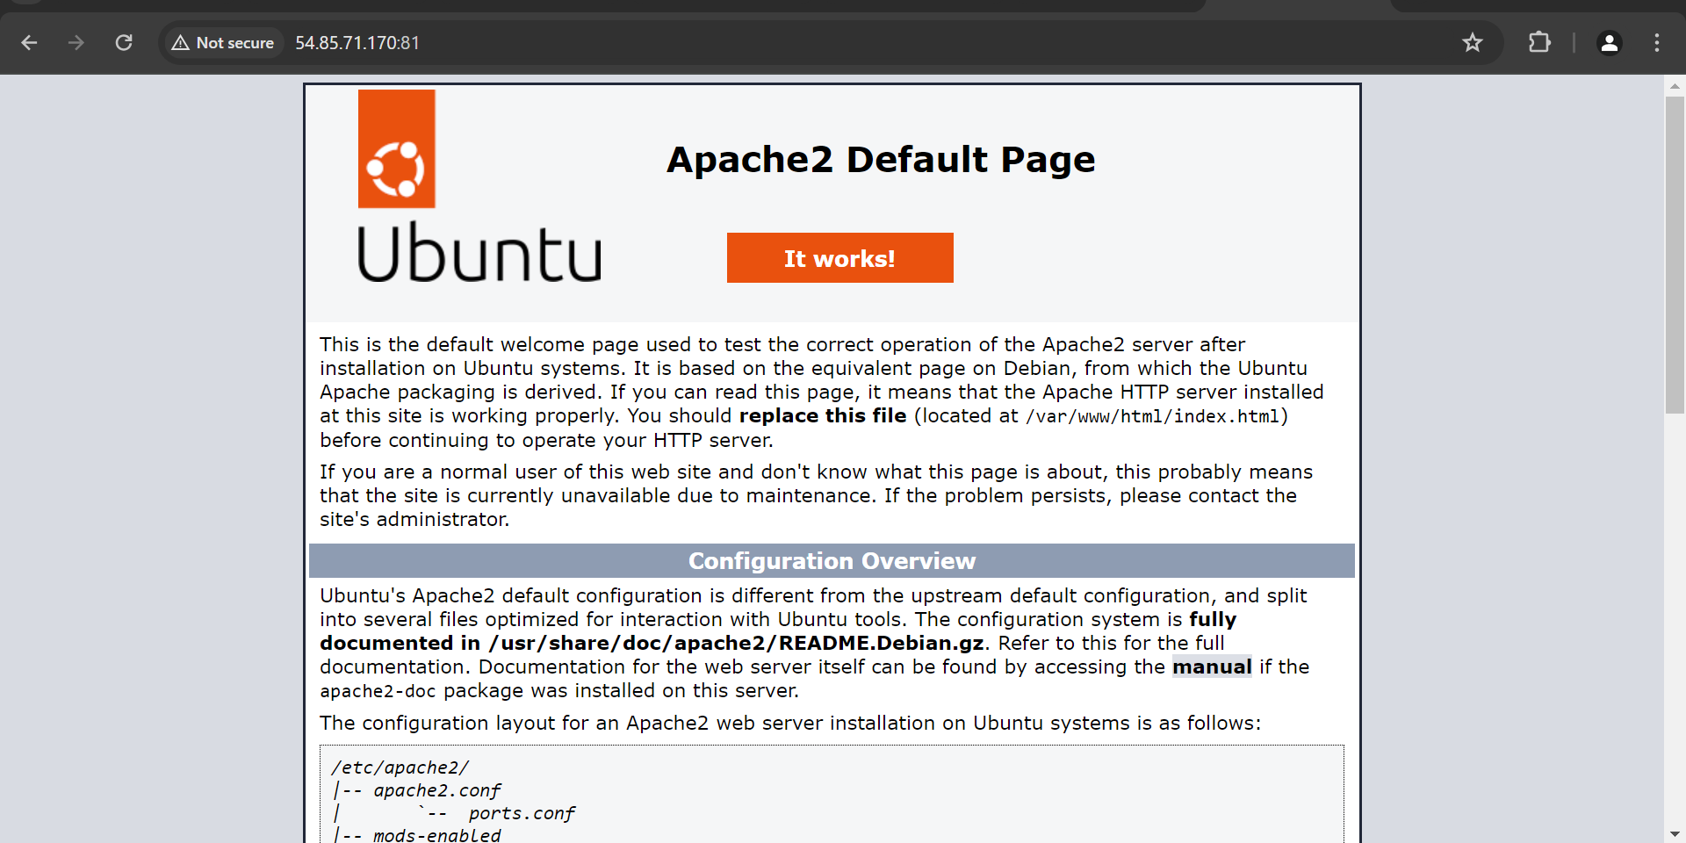

[root@ip-172-31-22-207 ec2-user]# docker ps

CONTAINER ID IMAGE COMMAND CREATED STATUS PORTS NAMES

a9df3d19dd53 ubuntu "/bin/bash" 14 minutes ago Up 13 minutes 0.0.0.0:80->80/tcp, :::80->80/tcp my-apache-container

[root@ip-172-31-22-207 ec2-user]# docker ps

CONTAINER ID IMAGE COMMAND CREATED STATUS PORTS NAMES

a9df3d19dd53 ubuntu "/bin/bash" 14 minutes ago Up 13 minutes 0.0.0.0:80->80/tcp, :::80->80/tcp my-apache-container

[root@ip-172-31-22-207 ec2-user]# docker commit a9df3d19dd53 apache-image:new

sha256:2c1abdeb817451d2c6b3d864ce8d7ddc35842a9715843b8a278ba37ad146d420

[root@ip-172-31-22-207 ec2-user]# docker images

REPOSITORY TAG IMAGE ID CREATED SIZE

apache-image new 2c1abdeb8174 5 seconds ago 237MB

ubuntu latest 7af9ba4f0a47 13 days ago 77.9MB

[root@ip-172-31-22-207 ec2-user]# docker run -it -p 81:80 --name new-container apache-image:new

root@6a9c41df175b:/# service apache2 start

* Starting Apache httpd web server apache2 AH00558: apache2: Could not reliably determine the server's fully qualified domain name, using 172.17.0.3. Set the 'ServerName' directive globally to suppress this message

*

root@6a9c41df175b:/# service apache2 status

* apache2 is running

root@6a9c41df175b:/# exit

exit

[root@ip-172-31-22-207 ec2-user]# docker ps

CONTAINER ID IMAGE COMMAND CREATED STATUS PORTS NAMES

a9df3d19dd53 ubuntu "/bin/bash" 19 minutes ago Up 17 minutes 0.0.0.0:80->80/tcp, :::80->80/tcp my-apache-container

[root@ip-172-31-22-207 ec2-user]# docker ps -a

CONTAINER ID IMAGE COMMAND CREATED STATUS PORTS NAMES

6a9c41df175b apache-image:new "/bin/bash" 2 minutes ago Exited (0) 19 seconds ago new-container

a9df3d19dd53 ubuntu "/bin/bash" 19 minutes ago Up 18 minutes 0.0.0.0:80->80/tcp, :::80->80/tcp my-apache-container

[root@ip-172-31-22-207 ec2-user]# docker exec -it new-container /bin/bash

Error response from daemon: container 6a9c41df175b78140bc732a58af98d38cc3bdd0eb2ebb4d5bf577e32c4c923a8 is not running

[root@ip-172-31-22-207 ec2-user]# docker rm 6a9c41df175b

6a9c41df175b

[root@ip-172-31-22-207 ec2-user]# docker run -it -p 81:80 --name new-container apache-image:new /bin/bash

root@dd8591fd6585:/# service apache2 status

* apache2 is not running

root@dd8591fd6585:/# service apache2 start

* Starting Apache httpd web server apache2 AH00558: apache2: Could not reliably determine the server's fully qualified domain name, using 172.17.0.3. Set the 'ServerName' directive globally to suppress this message

*

root@dd8591fd6585:/# service apache2 status

* apache2 is running

root@dd8591fd6585:/# exit

exit

[root@ip-172-31-22-207 ec2-user]# docker ps

CONTAINER ID IMAGE COMMAND CREATED STATUS PORTS NAMES

a9df3d19dd53 ubuntu "/bin/bash" 22 minutes ago Up 21 minutes 0.0.0.0:80->80/tcp, :::80->80/tcp my-apache-container

[root@ip-172-31-22-207 ec2-user]# docker ps -a

CONTAINER ID IMAGE COMMAND CREATED STATUS PORTS NAMES

dd8591fd6585 apache-image:new "/bin/bash" About a minute ago Exited (0) 20 seconds ago new-container

a9df3d19dd53 ubuntu "/bin/bash" 22 minutes ago Up 21 minutes 0.0.0.0:80->80/tcp, :::80->80/tcp my-apache-container

[root@ip-172-31-22-207 ec2-user]# docker rm dd8591fd6585

dd8591fd6585

[root@ip-172-31-22-207 ec2-user]# docker run -d -p 81:80 --name new-container apache-image:new /usr/sbin/apache2ctl -D FOREGROUND

9f6ed9c566fb81df20ce801c9e1713e27bab832895409aa167193e694b8037a4

[root@ip-172-31-22-207 ec2-user]# docker ps

CONTAINER ID IMAGE COMMAND CREATED STATUS PORTS NAMES

9f6ed9c566fb apache-image:new "/usr/sbin/apache2ct…" 6 seconds ago Up 5 seconds 0.0.0.0:81->80/tcp, :::81->80/tcp new-container

a9df3d19dd53 ubuntu "/bin/bash" 25 minutes ago Up 23 minutes 0.0.0.0:80->80/tcp, :::80->80/tcp my-apache-container

[root@ip-172-31-22-207 ec2-user]#